**3.1. Need for Testing as a separate stream and Testing as a Profession**

Testing is part of overall Quality Assurance – It covers the Quality Control aspect of ensuring Quality. It provides sufficient information to the stake holders for decision making regarding release of the software/ system, for the next development step or handover to customers. Testing is not just plain documentation. It is understanding the domain and application functionality. coding in case of Automation.Testing is breaking the code to make better solutions.

**Need for Testing as a separate stream**

•    The testing team needs to be independent and empowered in order to be effective.

•    SeparateTesting team would have people having sufficient knowledge and ability to test the software

•     Testers would have independent view about the work products derived from requirement statement

•    Developers tend to be optimistic while developing s/w that right and correct input will be given to the s/w while testing.

•    There may be blindfolds while understanding requirements or selection of approach, and developers may not be willing to find more defects.

•    Understanding approach related defects may not be found by developers.  
•    Platform or database related defects may not be uncovered as developers may feel that as a technological limitations. As per developers, technology is creating problems.

•    Developers have more of creation skills while testing needs more of a destruction skill

•    Special skills required for doing special tests would be available in independent testing teams.

**Testing as a Profession**

The Wrong Notion:

The Reality:

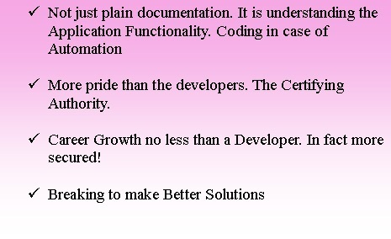

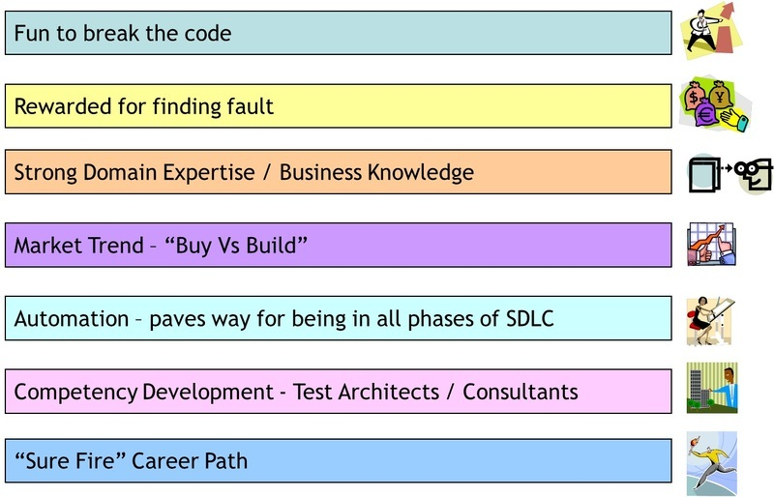

**3.2. Building a career in Testing**

The below points to be noted for building a career in Testing

•    Understand the Testing Principles  
•    Have the right mind set and set up own goals  
•    Learn testing processes & methodologies  
•    Take training on testing tools  
•    Take professional training on software testing  
•    Complete software testing certifications  
•    Learn the Domain  
•    Move up in the hierarchy

Behind every great Developer there is an equally great Tester.

**Professional Certifications in Testing**

Training & Certification makes a better Test Professional. Assurance Academy which is part of the Assurance Services Unit caters to the competency development in software testing in TCS.

Below is the list of some of the widely taken up certifications in Testing

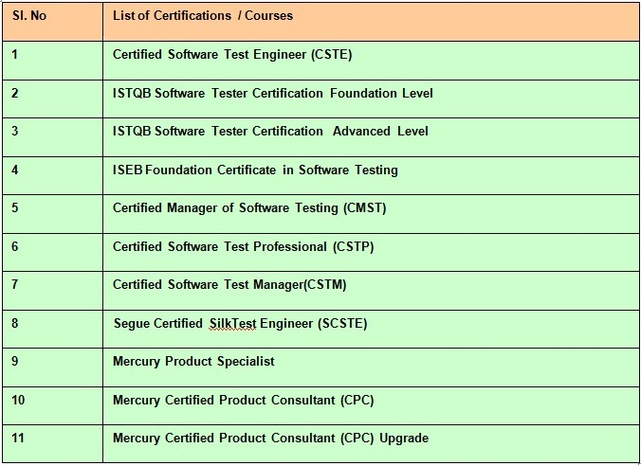

**Roles and Responsibilities**

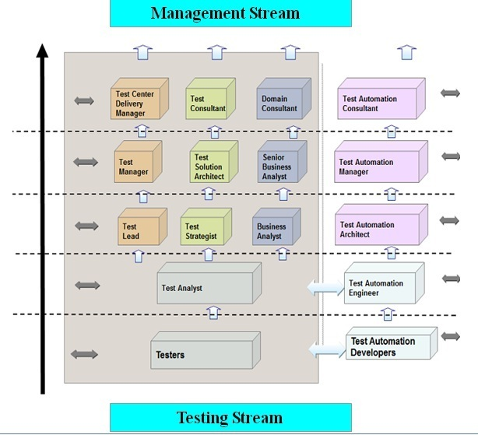

**Test Engineer / Tester**

•    Execute test cases as per test plans and log defects  
•    Work closely with Test Lead / Analyst to achieve desired objectives

**Test Analyst**

•    Develop Test Cases, Test Scripts and Test Data  
•    Prepare traceability matrix   
•    Work closely with Testing team to achieve the desired test result

**Test Lead**

•    Develop and manage Test Plans  
•    Monitor test execution and track defects  
•    Establish Testing Environment, processes and implement methodologies  
•    Report status of testing and co-ordinate with end-users, testers and test manager

**Test Automation Engineer**

•    Prepare test automation design based on the test automation architecture and framework defined for the project  
•    Define standards and guidelines for automation

**Test Strategist**

•    Design testing framework including automated testing  
•    Review testing deliverables  
•    Analyze testing tools and recommend for use  
•    Define test strategy  
•    Define Metrics

**Test Process Consultant**

•    Assess testing processes and recommend improvement action plan  
•    Assess test automation feasibility   
•    Prepare assessment plan and coordinate with the project/program stakeholders

**Test Manager**

•    Develop test strategy  
•    Planning, effort estimation, resource management and training  
•    Manage and deliver the Testing team activities  
•    Establish, track and improve process efficiencies  
•    Identifying risks and formulating mitigation strategies

**Business Analyst**

•    Prepare high level test scenarios based on business scenarios and requirements  
•    Analyze requirements for accuracy and completeness from a business perspective  
•    Review high level test scenarios prepared

**Test Consultant**

•    Assess testing processes and recommend improvement action plan  
•    Prepare assessment plan and coordinate with the project/programme stakeholders  
•    Pre-sales/ business development

**Test Automation Consultant**

•    Automation feasibility analysis and tool evaluation  
•    Automation approach and roadmap  
•    Pre-sales/ business development  
•    Creation of assets  
•    Product review/ keep abreast of developments in product space

**Test Center Delivery Manager**

•    End-to-end management of testing delivery for multiple projects / initiatives  
•    Identify and monitor issues, risks and concerns at test centre level  
•    Reporting to Customer Management  
•    Establish Client expectations  
•    End-to-end management of testing delivery  
•    Identify and monitor issues, risks and concerns at test centre level  
•    Reporting to Customer Management

**Latest trends in Testing**

Some of the major trends in software testing are as follows.

•    Mobile Usability testing  
•    Client side performance testing  
•    Automated cross browser testing  
•    Mobile performance testing  
•    Exploratory Testing  
•    Testing in the cloud

**3.3. Qualities of a Tester**

Not just anyone can claim to be an exceptional software tester. Software testing requires a unique skill set, and the best software testers are the ones that continuously strive to expand their knowledge and hone their testing strategies. In short, good testers always want to get better.

A Great Tester is one who wants to know more than the developers know to have that breaking edge.

Skills required to become a Software Tester

Following skills are indispensable to become a good software Tester.

•    Analytical Skills  
•    Technical skills  
•    Communication skills  
•    Attitude  
•    Productivity  
•    Passion

**Analytical Skills:**

A good software tester should have sharp analytical skills.Analytical skills will help break up a complex software system into smaller units to gain a better understanding and create corresponding test cases.

**Technical skills:**

A good software tester must have strong technical skills. It helps the testers to have a real insight into the kinds of bugs that come into software and the likeliest place to find them. Also Technical skills help in test Automation.

**Communication skills:**

A good software tester must have a good verbal and written communicationskills. It helps in creation of Testing artifacts like test cases, test plans, test strategies, bug reports. Also in communicating with developers, clients and management (Negotiation and Soft skills).

**Attitude:**

A good software tester should have a GREAT attitude.An attitude to Test to break, detail orientation, willingness to learn, suggest process improvements,  
upgrade technical skills with the changing technologies and work independently without much supervision.

**Productivity:**

A software tester must efficiently manage workload, have high productivity, exhibit optimal time management and organization skills.

**Passion:**

A software tester must have a great degree of passion for Testing. The passion should be, to make a career in testing but not just to treat it as a job.Only then one can excel in this profession.

